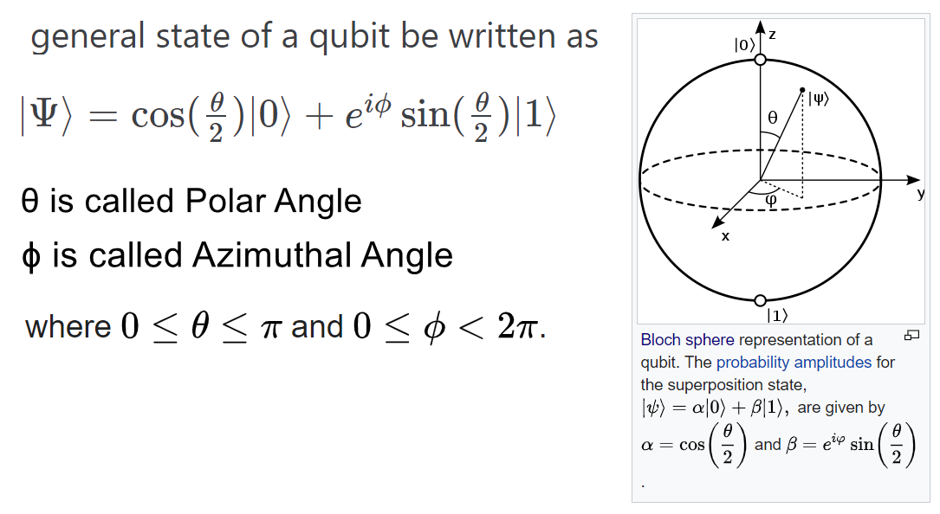

Proof:

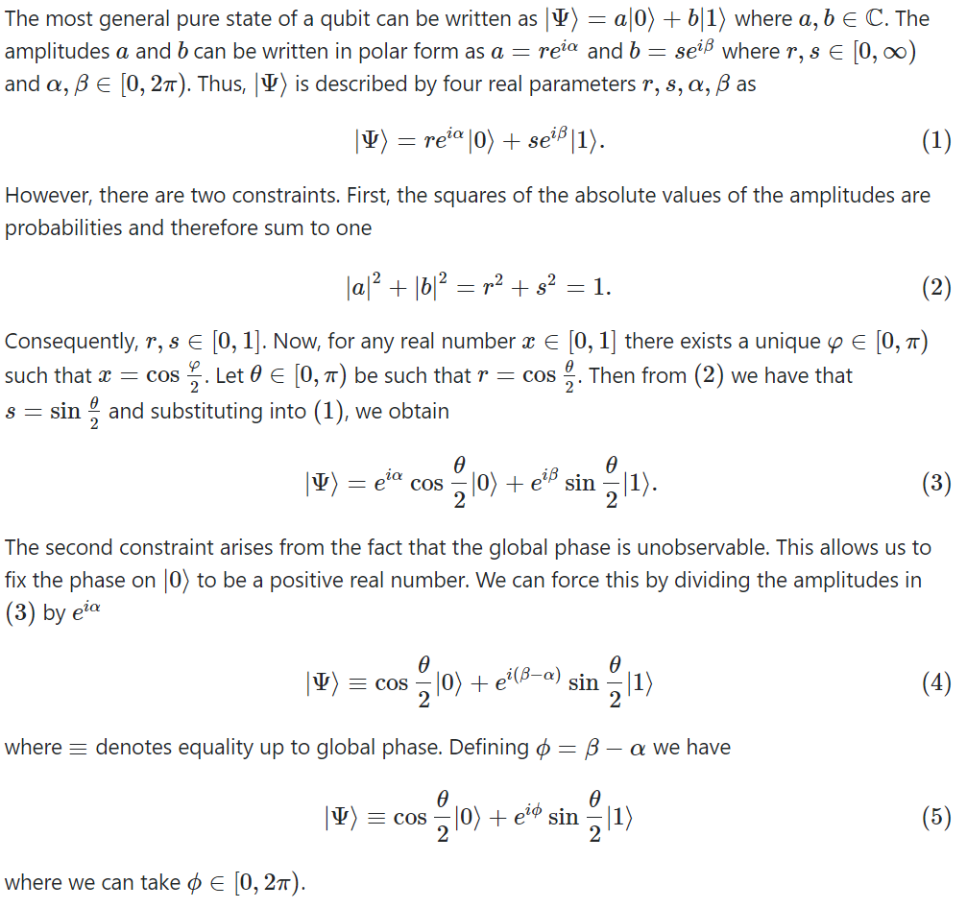

1) If a qubit pure state equation is given in the form of 

Find the polar and azimuthal angles.

**Step 1**: Write the complex numbers (a and b) in exponential form.

**Step 2**: If **a** is not real number, then factor out exponential term from factor of |0>. This phase factor is called the global phase and it can be ignored. (See. Thomas Wong Page 93 Topic#2.4.2)

**Step 3**: Equate and find the theta and phi.

**2) Spherical to Rectangular Coordinates:**

Given spherical parameters **(r, θ, Φ)** for a Qubit, find the Rectangular coordinates **(x,y,z)**:

**Note**: Here **θ** is called ***Polar*** Angle (0-180˚) and **Φ** is called ***Azimuthal*** Angle (0-360˚).

**x = r cos (φ) sin (θ)**

**y = r sin (φ) sin (θ)**

**z = r cos (θ)**

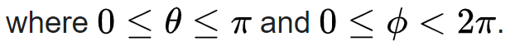

And Qubit equation becomes:

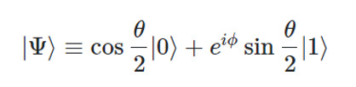

**3) Rectangular to Spherical Coordinates:**

Given a point on Bloch sphere with Rectangular coordinates **(x,y,z)**,

find the spherical parameters **(r, θ, Φ)**:

**Note**: Here **θ** is called ***Polar*** Angle (0-180˚) and **Φ** is called ***Azimuthal*** Angle (0-360˚).

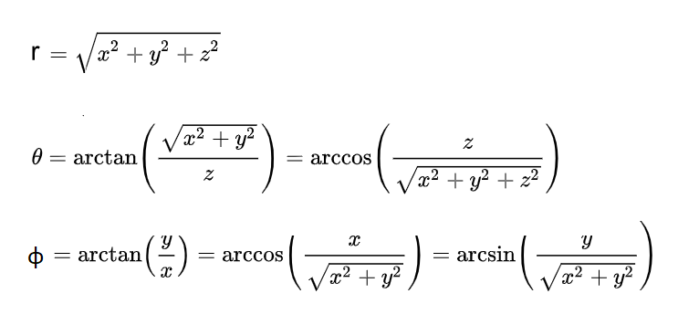

And Qubit equation becomes:



**4) Rotation about any axis by any angle on Single Qubit:**

